Project: Diamond Prices

Complete each section. When you are ready, save your file as a PDF document and submit it in your classroom.

# Step 1: Understanding the Model

*Answer the following questions:*

1. According to the model, if a diamond is 1 carat heavier than another with the same cut, how much more should I expect to pay? Why?

**Based on the regression model I created in excel you would expect to pay an extra amount of 8,413. Which means the price increase when the carat increases in a diamond.**

1. If you were interested in a 1.5 carat diamond with a **Very Good** cut (represented by a 3 in the model) and a **VS2** clarity rating (represented by a 5 in the model), how much would the model predict you should pay for it?

**Based on the regression equation here is the answer**

**Price = -5,269 +8,413 x carat + 158.1 x cut + 454 x clarity .**

**The answer will be $10,094.8**

# Step 2: Visualize the Data

Make sure to plot and include the visualizations in this report. For example, you can create graphs in Excel and copy and paste the graphs into this Word document.

1. Plot 1 - Plot the data for the diamonds in the database, with carat on the x-axis and price on the y-axis.

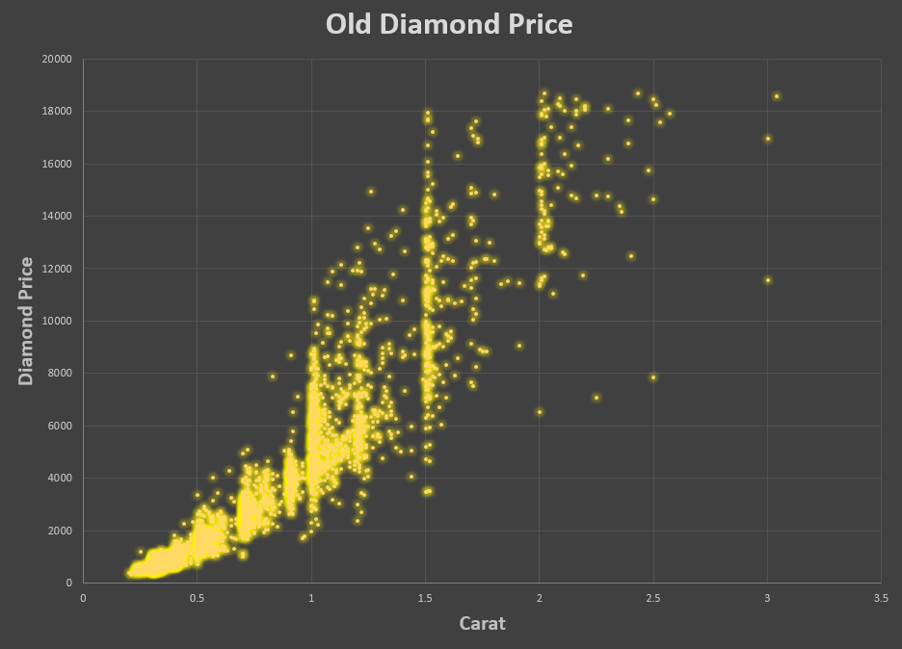

1. Plot 2 - Plot the data for the diamonds for which you are predicting prices with carat on the x-axis and predicted price on the y-axis.
   * **Note**: You can also plot both sets of data on the same chart in different colors.

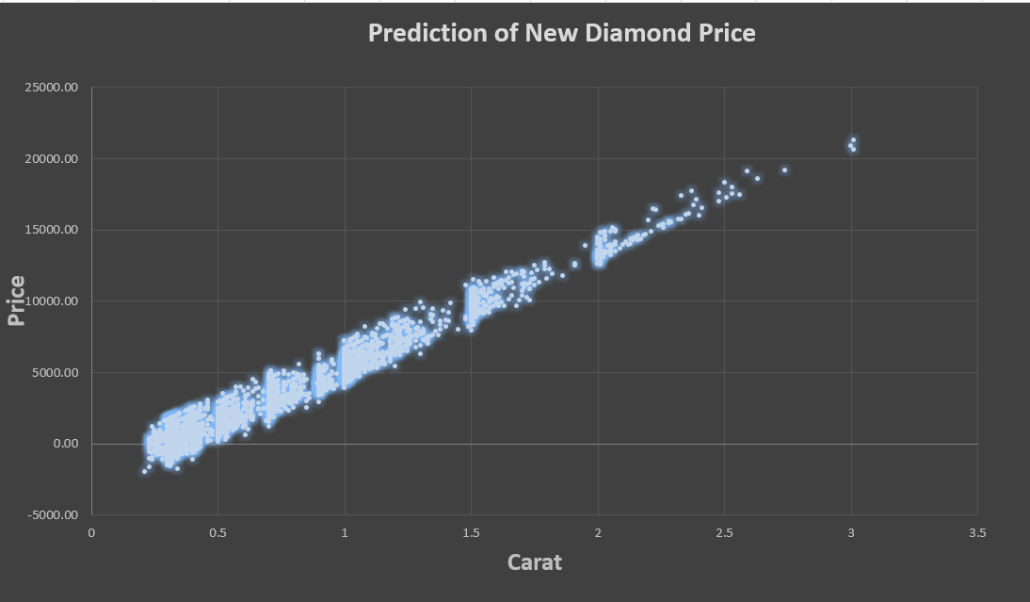

1. What strikes you about this comparison? After seeing this plot, do you feel confident in the model’s ability to predict prices?

**There is a strong positive correlation between prices and carat in the new diamond prices. However, there are some negative values in the prediction which it is not a proper way to use linear regression. In addition, the old prices don’t have a strong correlation even though there are other factors that affects the prices such as cut, clarity**.

# Step 3: Make a Recommendation

*Answer the following questions:*

1. What price do you recommend the jewelry company to bid? Please explain how you arrived at that number.

The bid should be = **$8,2134695.932**

When I calculated the sum of the prediction diamond prices it’s **$11733522.76** the company buy the diamond for %70 of the actual price and make %30 profit. When we calculate the numbers we get **$8,2134695.932**, which is the price for diamonds I recommend the jeweler to bid on the diamonds.